MATHEMATICS METHODS

MAWA Semester 2 (Unit 3&4) Examination 2018
Calculator-free

Marking Key

© MAWA, 2018
Licence Agreement
This examination is Copyright but may be freely used within the school that purchases this licence.
- The items that are contained in this examination are to be used solely in the school for which they are purchased.
- They are not to be shared in any manner with a school which has not purchased their own licence.
- The items and the solutions/marking keys are to be kept confidentially and not copied or made available to anyone who is not a teacher at the school. Teachers may give feedback to students in the form of showing them how the work is marked but students are not to retain a copy of the paper or marking guide until the agreed release date stipulated in the purchasing agreement/licence.

The release date for this exam and marking scheme is
- the end of week 1 of term 4, Fri October 12th 2018

Section One: Calculator-free (54 Marks)

Question 1 (a) (3 marks)
Solution
Mathematical behaviours | Marks
- integrates square root function correctly  - substitutes limits into correct anti-derivative  - evaluates result | 1  1  1

Question 1 (b) (2 marks)
Solution
Mathematical behaviours | Marks
- anti-differentiates correctly  - substitutes in to determine c | 1  1

Question 1 (c) (2 marks)
Solution
Mathematical behaviours | Marks
- applies the fundamental theorem  - evaluates result | 1  1

Question 2 (a) (2 marks)
Solution
Mathematical behaviours | Marks
- states that 63% represents 2 std deviations above the mean  - determines number of students above Joanne | 1  1

Question 2 (b) (2 marks)
Solution
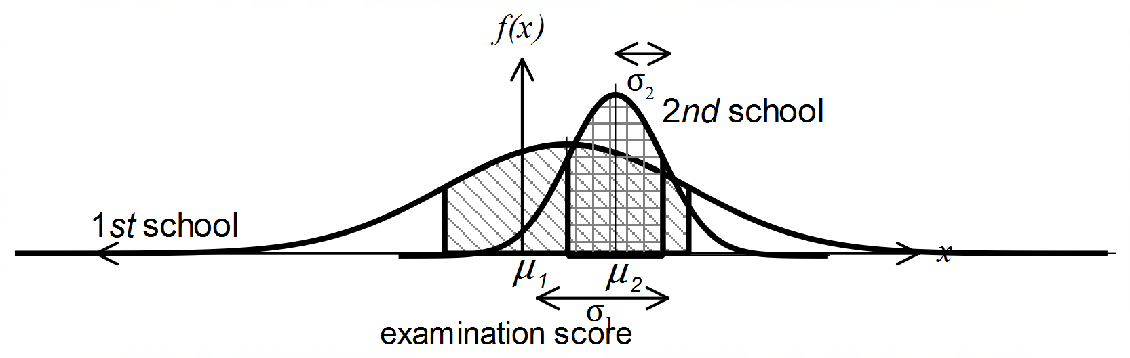

Mathematical behaviours | Marks
- diagram demonstrates that both distributions are normally distributed and  - diagram clearly depicts | 1  1

Question 2 (c) (3 marks)
Solution
Mathematical behaviours | Marks
- uses standard deviations to determine a  - states equation needed to solve for b  - determines b value | 1  1  1

Question 3 (a) (2 marks)
Solution
X | 5 | (-3)
P(X=x) | $$\frac{1}{4}$$ | $$\frac{3}{4}$$
.
Mathematical behaviours | Marks
- correct entries for X values  - determines probabilities correctly | 1  1

Question 3 (b) (2 marks)
Solution
E(X) = $5×\frac{1}{4}+(-3)×\frac{3}{4}$
= $\frac{5}{4}-\frac{9}{4}$
= (-1)
On average, Michael will lose $1 per toss
Mathematical behaviours | Marks
- determines expected gain correctly  - explains meaning of the negative value | 1  1

Question 3 (c) (2 marks)
Solution
With a loss of $1 per toss, this is not a “fair” game.

A game is considered “fair” if Michael will, on the average, come out even.
That is, an expected gain of zero will define a “fair” game.

Mathematical behaviours | Marks
- states game is “not fair”  - valid explanation | 1  1

Question 4 (a) (3 marks)
Solution
.
Mathematical behaviours | Marks
- rearranges equation and writes in exponential form  - applies log laws to each term of equation  - rearranges equation to arrive at result | 1  1  1

Question 4 (b) (3 marks)
Solution
.
Mathematical behaviours | Marks
- uses $a^{m}.a^{n}=a^{m+n}$ and $a^{\log_{a}b}=b$  - expresses $\log_{\frac{1}{5}}125 as \log_{\frac{1}{5}}{(\frac{1}{5})}^{-3}$, hence value of (-3)  - evaluates expression | 1  1  1

Question 5 (a) (3 marks)
Solution
$$y=ln\sqrt{3x-x^{2}}$$
= $\frac{1}{2}ln⁡(3x-x^{2})$
$\frac{dy}{dx}=\frac{1}{2}.\frac{1}{(3x-x^{2})}.\frac{(3-2x)}{1}$ = $\frac{(3-2x)}{2(3x-x^{2})}$
Mathematical behaviours | Marks
- expresses $y=ln\sqrt{3x-x^{2}}$as $y=\frac{1}{2}ln⁡(3x-x^{2})$  - uses  - applies chain rule correctly and simplifies | 1  1  1

Question 5 (b) (3 marks)
Solution
$\int_{0}^{\frac{π}{4}}{\frac{sin2x}{1+\sin^{2}x}}dx$ =$\int_{0}^{\frac{π}{4}}{\frac{2sinxcosx}{1+\sin^{2}x}}dx$
=${ln\left|1+\sin^{2}x\right|}_{0}^{π/4}$
=$ln\left|1+\frac{1}{2}\right|-ln\left|1\right|$
= $ln\frac{3}{2}$ or $ln 3$ - $ln 2$
Mathematical behaviours | Marks
- states anti-derivative of function with bounds  - substitutes in limits of integration correctly using  - evaluates result | 1  1  1

Question 5 (c) (4 marks)
Solution
Mathematical behaviours | Marks
- states correct derivative  - integrates both sides  - applies Fundamental Theorem  - rearranges to arrive at correct result | 1  1  1  1

Question 6 (a) (2 marks)
Solution
Mathematical behaviours | Marks
- identifies that each toss must result in a head  - determines probability | 1  1

Question 6(b) (4 marks)
Solution
Mathematical behaviours | Marks
- identifies that $\hat{p}$ will be normally distributed  - determines mean and standard deviation for distribution of $\hat{p}$  - determines Z score associated with  - determines probability | 1  1  1  1

Question 6 (c) (3 marks)
Solution
$P\left(\hat{p_{1}}=\hat{p_{2}}\right)=P\left(\hat{p_{1}}=\hat{p_{2}}=0\right)+P\left(\hat{p_{1}}=\hat{p_{2}}=\frac{1}{3}\right)+P\left(\hat{p_{1}}=\hat{p_{2}}=\frac{2}{3}\right)+P\left(\hat{p_{1}}=\hat{p_{2}}=1\right)$ (*)
$={\left(P(\hat{p_{1}}=0\right)}^{2}+{\left(P(\hat{p_{1}}=1/3\right)}^{2}+{\left(P(\hat{p_{1}}=2/3\right)}^{2}+{\left(P(\hat{p_{1}}=1\right)}^{2}$ (**)
$={\left(\frac{1}{8}\right)}^{2}+{\left(\frac{3}{8}\right)}^{2}+{\left(\frac{3}{8}\right)}^{2}+{\left(\frac{1}{8}\right)}^{2}=\frac{20}{64}=\frac{5}{16}$
Mathematical behaviours | Marks
- determines $\hat{p}$ values  - states calculation required to determine probability  - evaluates required sum | 1  1  1

Question 7 (a) (4 marks)
Solution
$f^{'}\left(x\right)=3x^{2}e^{-x}-x^{3}e^{-x}=x^{2}\left(3-x\right)e^{-x}$
$f^{'}\left(x\right)=0$ $x=0$ or $x=3.$
, so $f$ has stationary points at $\left(0,0\right)$ and at $(3,3^{3}e^{-3})$
x | 3⁻ | 3 | 3⁺
 | +ve | 0 | -ve
Since $f'(x)≥0$ if $x<3$ and $f^{'}\left(x\right)<0$ if $x>3,$
$f$ has a point of inflection at $\left(0,0\right)$
and $f$ has a local maximum at $(3,3^{3}e^{-3})$
Mathematical behaviours | Marks
- differentiates correctly  - equates and determines co-ordinates of stationary points  - justifies nature of first stationary point  - justifies nature of 2nd stationary point | 1  1  1  1

Question 7 (b) (2 marks)
Solution
Yes.
Reason: $f\left(3\right)=3^{3}e^{-3}={\left(\frac{3}{e}\right)}^{3}>1$ since $0<e<3$
Mathematical behaviours | Marks
- gives correct answer  - gives a valid reason | 1  1

Question 7 (c) (3 marks)
Solution
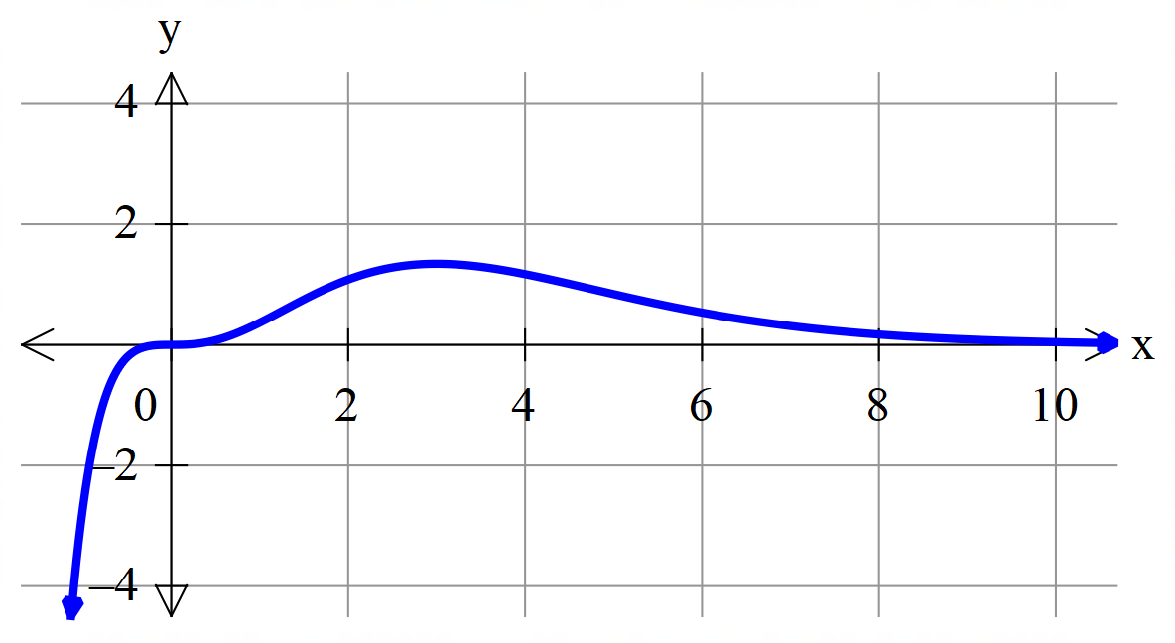

Mathematical behaviours | Marks
- shows inflection point at origin  - shows maximum at $x=3$  - shows correct limits as $x→∞$ and $x→-∞$ | 1  1  1

